Quick guide to use M5 RGB LED
- Download and use the latest libraries from Github repo (or manually install AdaFruit_NeoPixel library in Arduino IDE).
- Connect the LED module:
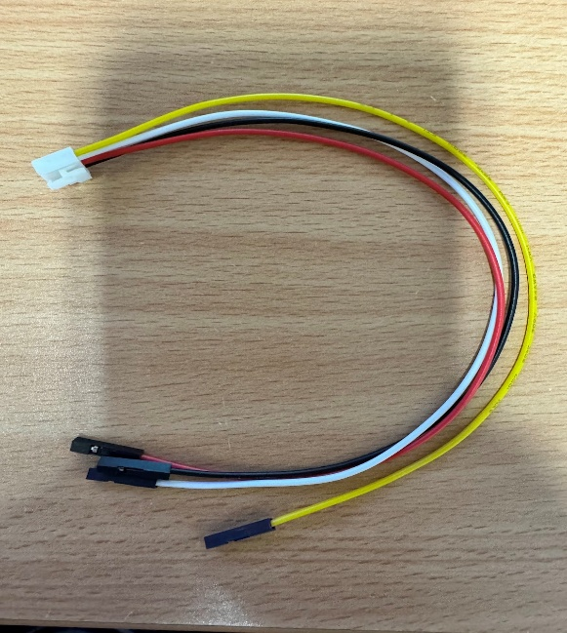
Use this cable

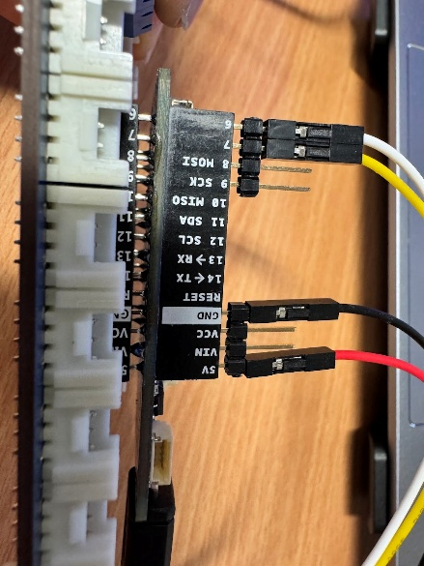
Connect the free-end (Black) connector cable to the Arduino Board using the provided gold-pin header.

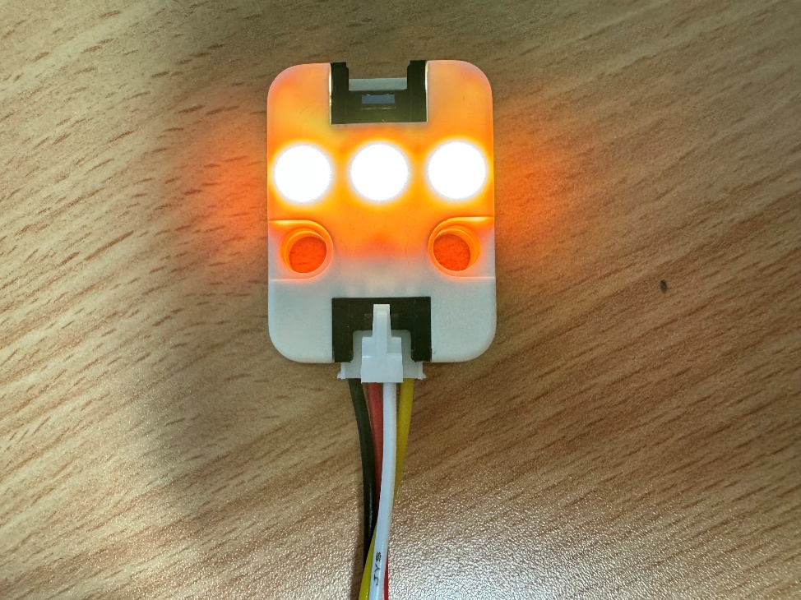
Connect the other end (white) of the connector cable to the LED Module (Take note to use the socket nearest to the module mounting holes).
- Run the sample program ( a copy is in github - lab4: rgb_led_simple):
#include <Adafruit_NeoPixel.h>
// Which pin on the Arduino is connected to the NeoPixels?
#define PIN 6 // On Trinket or Gemma, suggest changing this to 1

// How many NeoPixels are attached to the Arduino?
#define NUMPIXELS 3 // M5 RGB LED has only 3 LEDs

// When setting up the NeoPixel library, we tell it how many pixels,
// and which pin to use to send signals. Note that for older NeoPixel
// strips you might need to change the third parameter -- see the
// strandtest example for more information on possible values.
Adafruit_NeoPixel pixels(NUMPIXELS, PIN, NEO_GRB + NEO_KHZ800);

void setup()
{
pixels.begin(); // INITIALIZE NeoPixel strip object (REQUIRED)
}

void loop()
{
pixels.clear(); // Set all pixel colors to 'off'
pixels.show(); // Send the updated pixel colors to the hardware.
delay(2000); //

pixels.setPixelColor(0, pixels.Color(255, 0, 0)); // LED 0 - Red
pixels.setPixelColor(1, pixels.Color(0, 255, 0)); // LED 1 - Green
pixels.setPixelColor(2, pixels.Color(0, 0, 255)); // LED 2 - Blue
pixels.show(); // Send the updated pixel colors to the hardware.
delay(2000);
}

